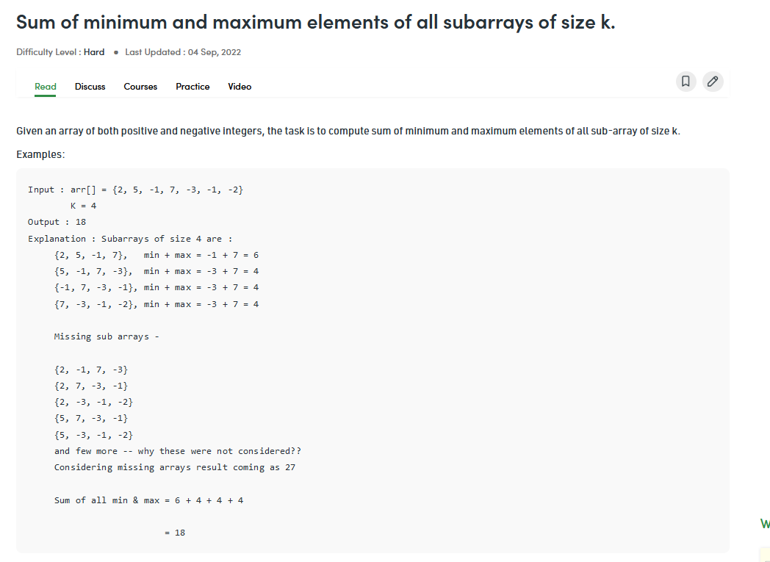

Here somewhat sliding window concept will take place.